# Instruction Manual for Lamplight

## Main Menu

In the main menu screen *figure (##)*, three options can be chosen: ‘play’, ‘map select’ and ‘quit’. All of which will take the player/s to the correct screen.

The ‘Play’ button will direct the player/s to character and team selection. Here the player/s need to choose a team and select a character of their liking and again press play to enter the game level.

The ‘Map Select’ button will direct to the map selection screen where a list of game levels can be chosen from, shown with a preview thumbnail and level name. *Shown in figure (##).*

The ‘Quit’ button stops and closes the application.

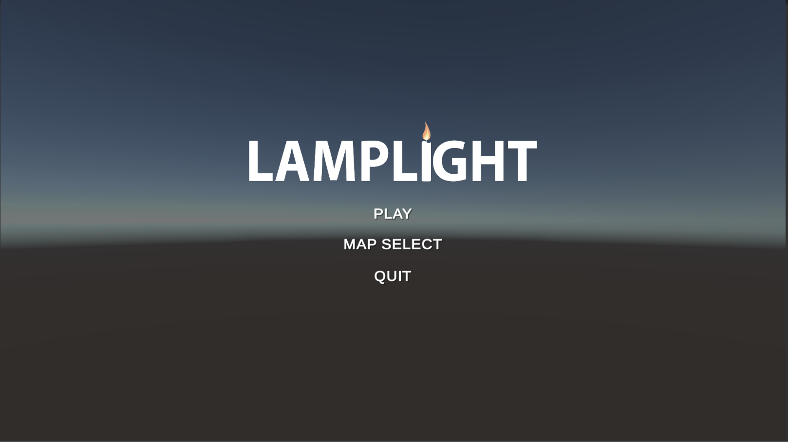 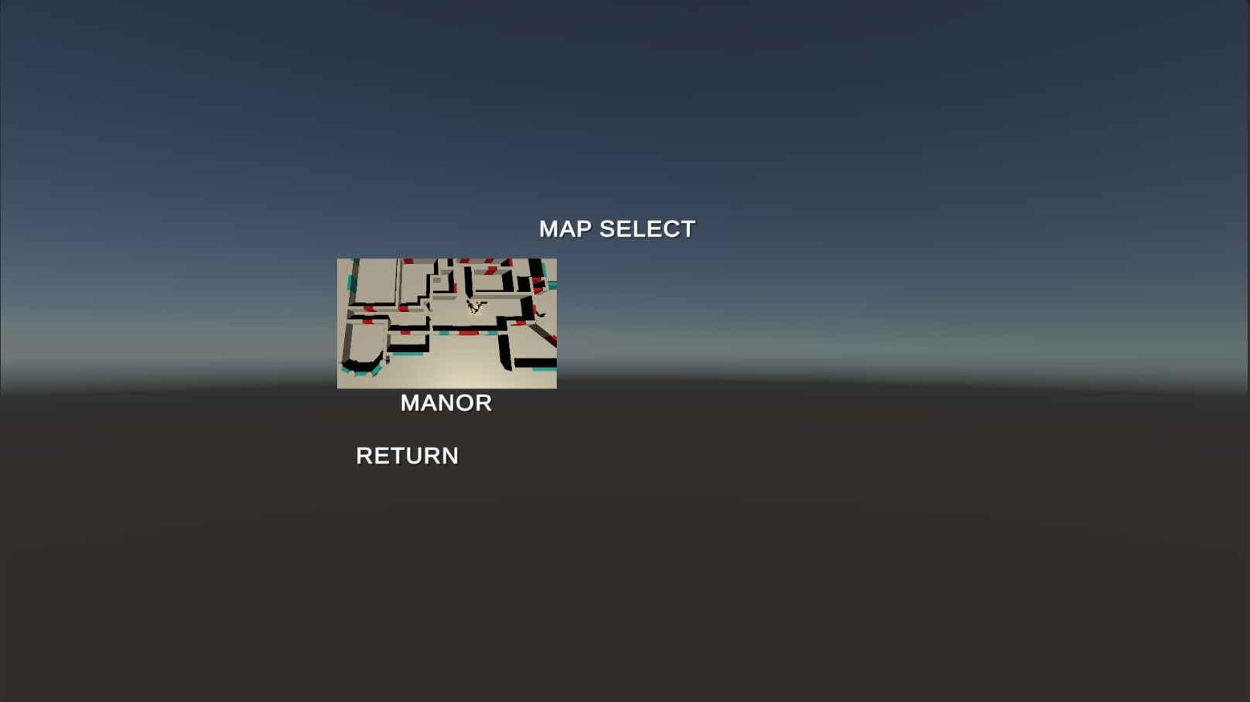

## Game Objectives

### Hunters

As a hunter, players must navigate through the map in search of oil lamps to light and need to capture ghosts. When all the lamps are lit, the hunters win. By lighting lamps, nearby ghosts become visible, giving the hunters a change to capture them with their net gun. Be careful, as ghosts can extinguish the lamps that are lit, no more lights mean game over.

### Hunters

As a ghost, keep the level in darkness by extinguishing all light sources in the level, whilst avoiding light sources near enemy hunters. Ghosts can fear hunters for a short period to give them an advantage in any situation – use this wisely! Captured ghosts can be freed with the help of an ally. An ally can stand close for a few seconds to free the captured ghosts.

## Character Controls

Player character movement can be controlled through using the virtual joystick shown on the air console user interface *(figure##)*. The hunter specific controls include net capture (button B) which can be used to throw a ghost net in the direction the player character is looking. Whereas the ghost’s specific ability button is a spook button, that can be used to scare the hunter character. Both player types have a fling button (button A) that can be used to toss in-game objects. Players can also leave the game by pressing the leave button (button x).

## 